PASS
Social Studies – Grade 7
Test 2
SC07SS070201
- The constitution that established the United States of America is the oldest written constitution used by any nation in the entire world. How old is this document?
 | * just over 200 years old
 | just over 2,000 years old
 | nearly 5,000 years old
 | nearly 15,000 years old

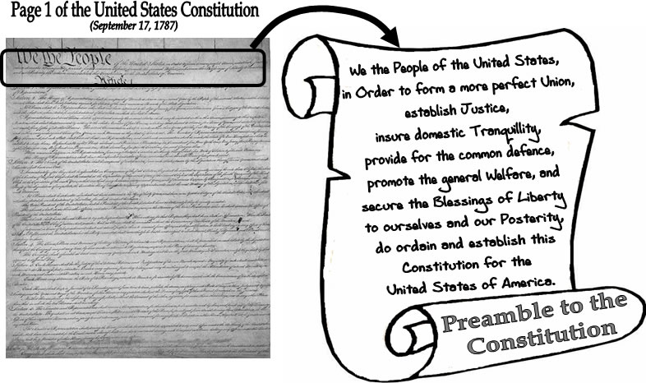
SC07SS070201
- Shown above is the preamble, or introduction, to the United States Constitution. The rest of the document went on to do which of the following?
explain the history of the government
* outline the structure of the government
describe the need for a strong government
persuade people to support the government

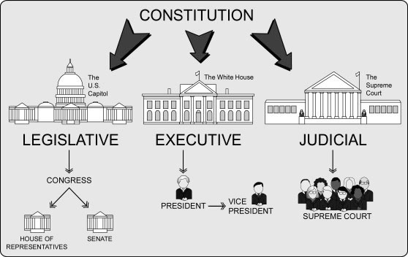
SC07SS070201
- The illustration above is describing which concept of the United States government that is dictated by its constitution?
the right to vote
separation of church and state
* separation of powers
freedom of speech and freedom of the press
SC07SS070205
- Fought between 1789 and 1799, the result of the French Revolution was viewed as a major victory for which of the following?
* the common man
the Roman Catholic Church
African slaves
the absolute monarch
SC07SS070205
- The inspiration for the United States Constitution and democratic government stems mostly from which period in history?
the Middle Ages
* the Enlightenment
the Age of Imperialism
the Industrial Revolution

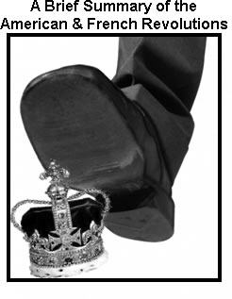
SC07SS070205
- The political cartoon shown above is making which of the following statements about the American Revolution and French Revolution during the late 18th century?
* in both revolutions, the monarchy was defeated by its citizens
in both revolutions, citizens protected the monarchy from danger
in both revolutions, common citizens became part of the monarchy
in both revolutions, the monarchy proved to be indestructible
SC07SS070301
- Which of the following was main cause of the French Revolution in the late 18th century?
the lack of oversight in political elections
the divided feelings over the American Revolution
the division of power among the powerful churches
* the imbalance of power between the social classes
SC07SS070301
- Which of the following was most responsible for King Louis XVI being viewed as a poor leader of France?
* his inability to control debt incurred through wars and over-spending
his violent crusade against Roman Catholic Church
his hatred for the history and traditions of France
his premature efforts to create a government "for the people and by the people"

SC07SS070301
- The Bastille was a fortress and prison used in Paris as early as the 14th century. Which symbolic event occurred on Bastille Day in France that helped define the course of the French Revolution?
* the King ordered that the Bastille be torn down
the King was put in prison in the Bastille
the peasants stole weapons and tore down the Bastille
the peasants were thrown in prison in the Bastille

SC07SS070301
- Which of the following accurately describes how Napoleon Bonaparte began his rise to power following the French Revolution?
he used the army to attack the French people, then he made himself their dictator
he used the army to become ruler of France, then turned his back on the citizens
* he used the army to become ruler of France, then helped organize the country
he recruited French citizens into his new army that overtook the existing one

SC07SS070302
- When did the Napoleonic Wars begin?
after Napoleon brought France to bankruptcy
* after Napoleon named himself emperor of France
after Napoleon gained the support of most European nations
after Napoleon eliminated all citizens' rights

SC07SS070302
- What was an immediate impact of the Napoleonic Wars?
spread of monarchies and absolute power
spread of industrialization and consumerism
* the spread of nationalism and the rise of revolutions
spread of democracy and common law

SC07SS070302
- What is the best definition for the "nationalism" that defined Europe in early 1800s?
a loyalty to a popular leader
* a loyalty to a shared culture
a loyalty to a strict government
a loyalty to a single religion

SC07SS070302
- Which of the following was a result of the Congress of Vienna from 1814 to 1815?
all lands taken by Napoleon were made a permanent part of France
* all lands taken by Napoleon were returned to their original nations
all lands taken by Napoleon were combined into a single nation
all lands taken by Napoleon were divided evenly to create new nations

SC07SS070303
- The Enlightenment and the success of the American Revolution prompted other revolutions around the world, such as those in Haiti, Mexico, and South America. Which of the following phrases best describes the thinking of revolutionaries at the time who were inspired by these events?
"Be careful what you wish for."
"Might makes right!"
"Better safe than sorry..."
* "Liberty for all!"

SC07SS070303
- What was unique about Haiti's independence battle that began in the late 1700s?
it was the first slave revolt in history
* it was the only successful slave revolt in history
it was the only slave revolt led by white citizens
it was a slave revolt without violence

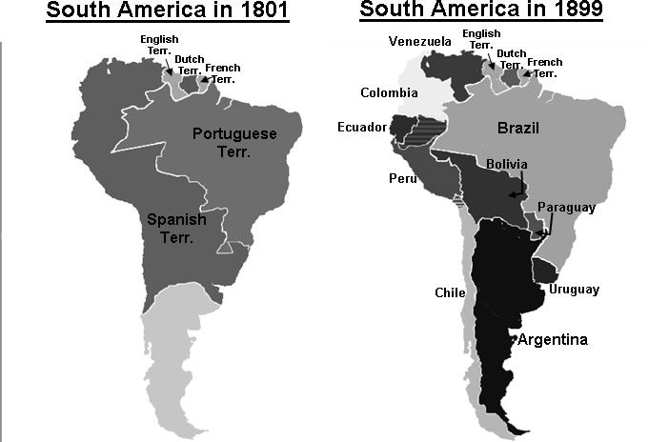
SC07SS070303
- Shown above is a map of South America at the start of the 19th century (on the left) and at the end of the 19th century (on the right). Which of the following is the reason for the vast changes in these two maps?
* the rise of Independence Movements in South America
the spread of European Imperialism in South America
the rapid innovations brought on by the Industrial Revolution
the widespread popularity in the idea of Manifest Destiny
SC07SS070303
- The maps above show that, by the end of the 19th century, the Spanish Territory in South America was largely replaced by the nations of Venezuela, Colombia, Ecuador, Peru, and Bolivia. Which of the following individuals was most responsible for organizing this transformation?
* Simon Bolivar
Miguel Hidalgo
Hernando Cortez
Zachary Taylor
SC07SS070304
- In the early 1700s, England embraced which of the following economic practices that helped spark the Industrial Revolution?
* free markets
socialism
communism
high tariffs

SC07SS070304
- Major innovations during the Industrial Revolution, such as mechanization and the introduction of the assembly line, helped manufacturers and businesses do which of the following with greater success?
avoid competition by producing less goods to sell in a small area
focus more on high quality hand-crafted & custom-made goods
quickly improve working conditions and increase hourly wages
* mass-produce goods and distribute them to a wide range of consumers

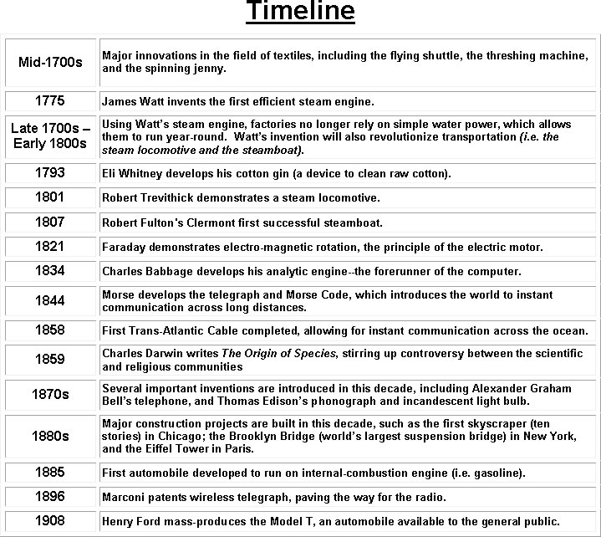

SC07SS070304
- The timeline shown above is covering which period in world history?
* the Industrial Revolution
the Age of Enlightenment
the Scientific Revolution
the Glorious Revolution

SC07SS070304
- The 18th and 19th century were defined by a number of groundbreaking inventions and new developments in mechanization. According to the timeline, which of the following started all of this?
the spread of democracy around the world
* advancements in the textile industry
the rise of labor unions
new legislation passed by congress
SC07SS070304
- Which of the following is NOT included on the timeline shown above that covers the 18th and 19th centuries?
new inventions and advancements during the period
the "snowball effect" of innovation during the period
major feats in construction and engineering during the period
* problems with industrialization that arose during the period
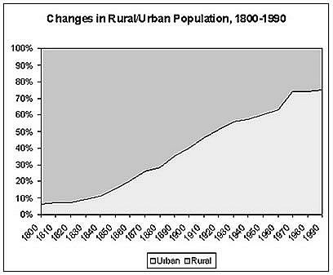
SC07SS070304
- The graph above can be used to show which trend that was sparked by the Industrial Revolution in the late 1700s?
* the widespread transition from the farms to the cities
the steadily falling price of farmland
the major impact of instant communication across long distances
the rising population in third world nations
SC07SS070305
- During the 19th century, which of the following was a major advantage for a European nation to form colonies throughout the world?
it helped simplify the economic & political structure of the nation
it avoided competition between other nations for international standing
it decreased the risk of a rebellion against the nation
* it gave a nation gain greater access to raw materials
SC07SS070305
- Which of the following statements best reflects the views behind that prompted the Open Door Policy at the end of the 19th century?
"Russia should force all countries in Eastern Europe to open their doors..."
* "China should open its doors and allow trade with more nations..."
"Japan should not allow its foreign policy to be such an open door..."
"The United States should only deal with countries that greet us with an open door..."

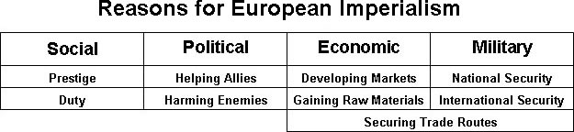
SC07SS070305
- During the 1800s, tensions formed between the British and Dutch who were both mining for diamonds in South Africa. According to the table above, which of the following prompted this example of European imperialism?
MILITARY --> International Security
* ECONOMIC --> Gaining Raw Materials
POLITICAL --> Helping Allies
SOCIAL --> Duty

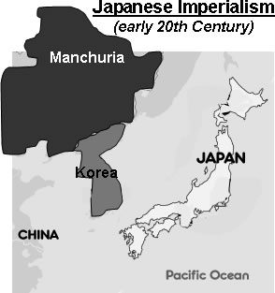
SC07SS070305
- Japanese expansion into Korea and Manchuria during the early 20th century was most threatening to which of these countries, eventually leading to a war?
United States
England
India
* Russia
SC07SS070305
- Japan's expansion into Manchuria and Korea in the early 1900s can best be described as which of the following?
mutually agreed upon and well-received
rapid, but without any military involvement
slow, cautious and peaceful
* rapid, aggressive, and with a strong military presence
SC07SS070306
- Definition: an extreme loyalty and devotion to one's country, that can often result in heavy promoting of one's culture and interests
Which of the following terms is being defined above?
colonialism
* nationalism
imperialism
globalism

SC07SS070306
- What effect did the Meiji Restoration have on Japan?
* Japan became an industrial nation and rose as a world power
Japan became more agricultural and lost its global influence
Japan became more agricultural and rose as a world power
Japan became an industrial nation and slowly lost its global influence

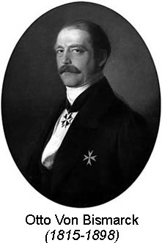
SC07SS070306
- As the Prussian President during the second half of the 19th century, Otto Von Bismarck (shown above) had what vision for the Germanic people in Europe?
he wanted to replace Germany with a larger European Union
* he wanted several Germanic states to unite into one nation
he wanted Germany to secede from Europe and join the United States
he wanted Germany to be divided into many states to spread the culture

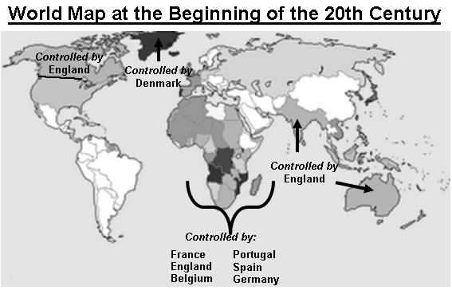
SC07SS070306
- The map above was designed to show which of the following at the start of the 20th century?
* the extent of European imperialism around the world
the impact of human development on the environment
the rise of global nationalistic movements
a comparison of urban and rural populations

SC07SS070306
- According to the above map, which part of the world was most under the control of European nations just over a century ago?
the Middle East
the United States of America
the continent of South America
* the continent of Africa

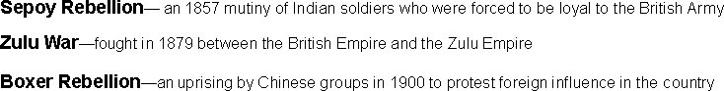
SC07SS070306
- The three revolts listed above were all a reaction to which of the following circumstances during the late 19th century?
the practice of apartheid
* prolonged European imperialism
the rise of Fascist governments
worldwide food shortages

SC07SS070306
- The three uprisings listed above are examples of native people in which parts of the world protesting foreign rule in the late 1800s?
North America and South America
* Asia and South Africa
Eastern Europe and Latin America
North Africa and the Middle East

SC07SS070307
- What did the Monroe Doctrine (1823) change?
* the availability of the American continent to European explorers and settlers
the profitability of natural resources in Central and South America
the difficulty of sailing from the east side of the American continent to the west side
the accessibility of America's big cities to European immigrants

SC07SS070307
- Instead of recognizing Cuba's independence in the late 1800s, the United States did which of the following?
* ran the country through a military government
issued a boycott on the import of all Cuban goods
annexed Cuba to temporarily become part of Florida
allowed American citizens to choose Cuba's new leader

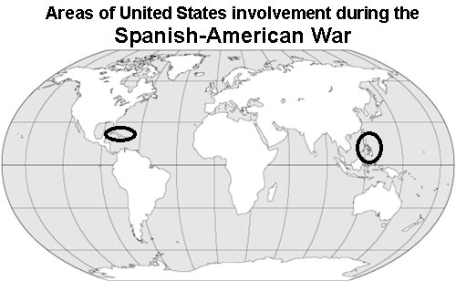
SC07SS070307
- Circled on the above map are two key areas of interest for the United States during the Spanish-American War. These two areas are which of the following?
Argentina and the Philippines
* Cuba and the Philippines
the Bahamas and Korea
Cuba and Japan

SC07SS070307
- How did the events of the Spanish-American War immediately change the relationship that the United States had with the two areas circled on the above map in the early 1900s?
the U.S. became isolationist and refused to give aid to the areas
the U.S. established new independent governments in the areas
the U.S. evacuated the areas and brought the refugees into America
* the U.S. extended its imperialistic control over the areas

